**Selenium**

**Day 5:**

**Task 1:**

package day_5;

import org.openqa.selenium.By;

import org.openqa.selenium.WebDriver;

import org.openqa.selenium.WebElement;

import org.openqa.selenium.chrome.ChromeDriver;

import org.openqa.selenium.chrome.ChromeOptions;

import org.openqa.selenium.interactions.Actions;

public class task1 {

public static void main(String[] args) {

System.setProperty("webdriver.chrome.driver","c://Drivers//chromedriver.exe" );

ChromeOptions co=new ChromeOptions();

co.addArguments("--remote-allow-origin=*");

WebDriver driver=new ChromeDriver(co);

driver.get("https://demoqa.com/droppable/");

Actions a=new Actions(driver);

WebElement source_ele=driver.findElement(By.id("draggable"));

WebElement dest_ele=driver.findElement(By.id("droppable"));

a.clickAndHold(source_ele).release(dest_ele).build().perform();

a.dragAndDrop(source_ele, dest_ele).build().perform();

}

}

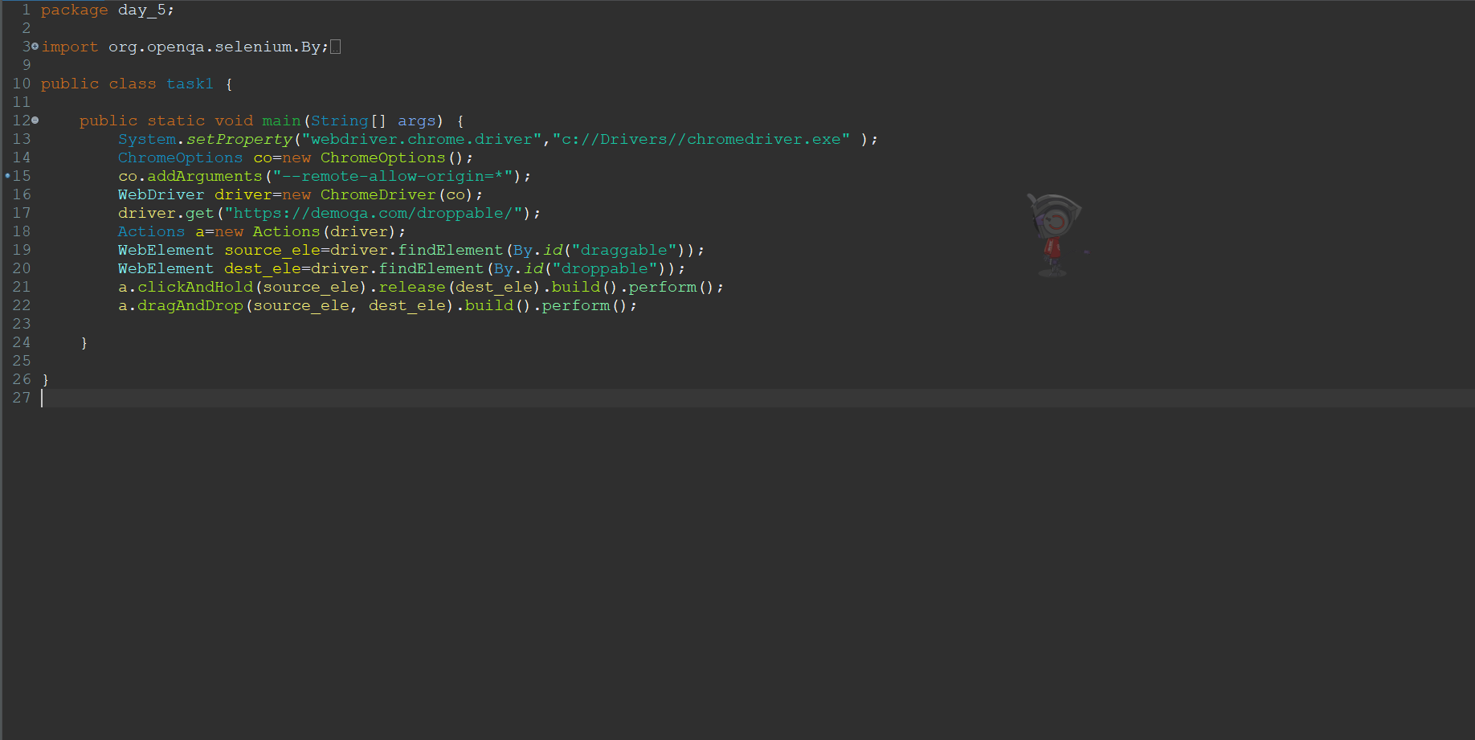

**Output:**

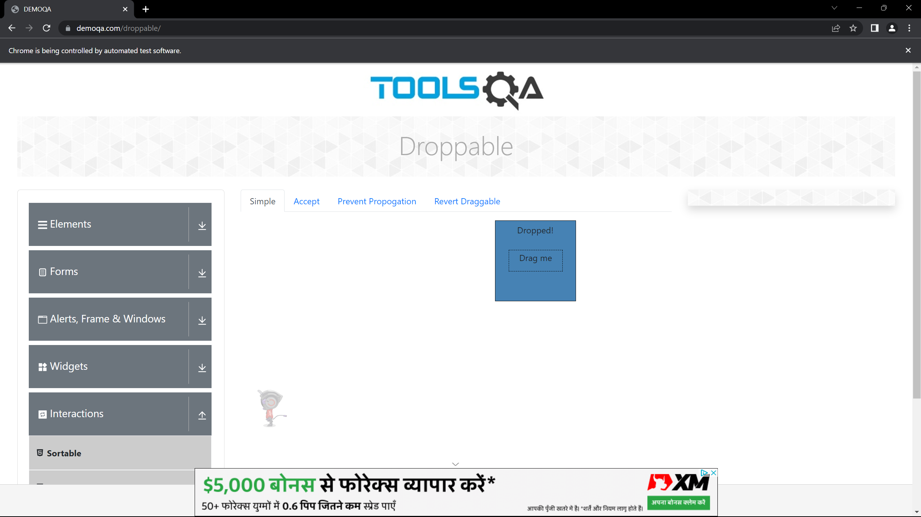

**Task 2:**

package day_5;

import org.openqa.selenium.By;

import org.openqa.selenium.WebDriver;

import org.openqa.selenium.WebElement;

import org.openqa.selenium.chrome.ChromeDriver;

import org.openqa.selenium.chrome.ChromeOptions;

import org.openqa.selenium.interactions.Actions;

public class task2 {

public static void main(String[] args) {

System.setProperty("webdriver.chrome.driver","c://Drivers//chromedriver.exe" );

ChromeOptions co=new ChromeOptions();

co.addArguments("--remote-allow-origin=*");

WebDriver driver=new ChromeDriver(co);

driver.get("https://jqueryui.com/droppable/");

driver.switchTo().frame(0);

Actions a=new Actions(driver);

WebElement source_ele=driver.findElement(By.id("draggable"));

WebElement dest_ele=driver.findElement(By.id("droppable"));

a.clickAndHold(source_ele).release(dest_ele).build().perform();

a.dragAndDrop(source_ele, dest_ele).build().perform();

}

}

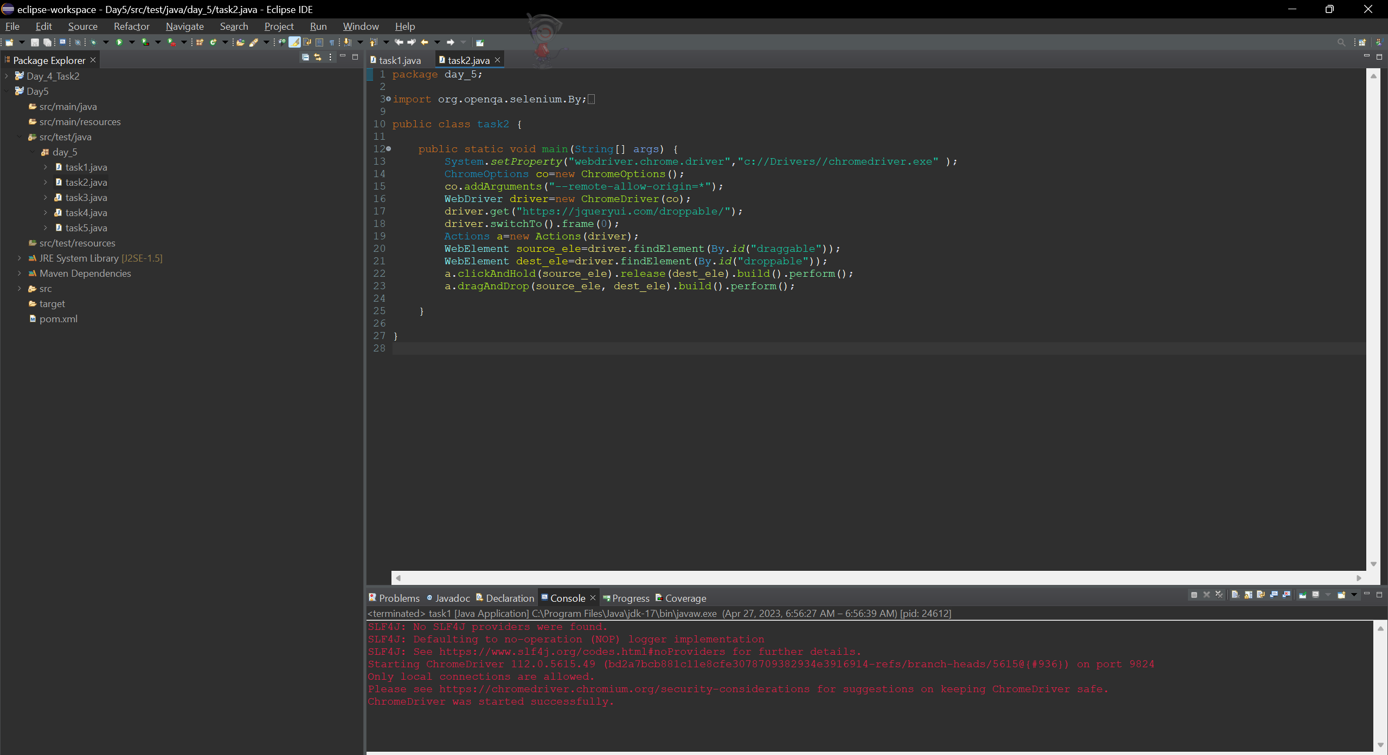

**Output:**

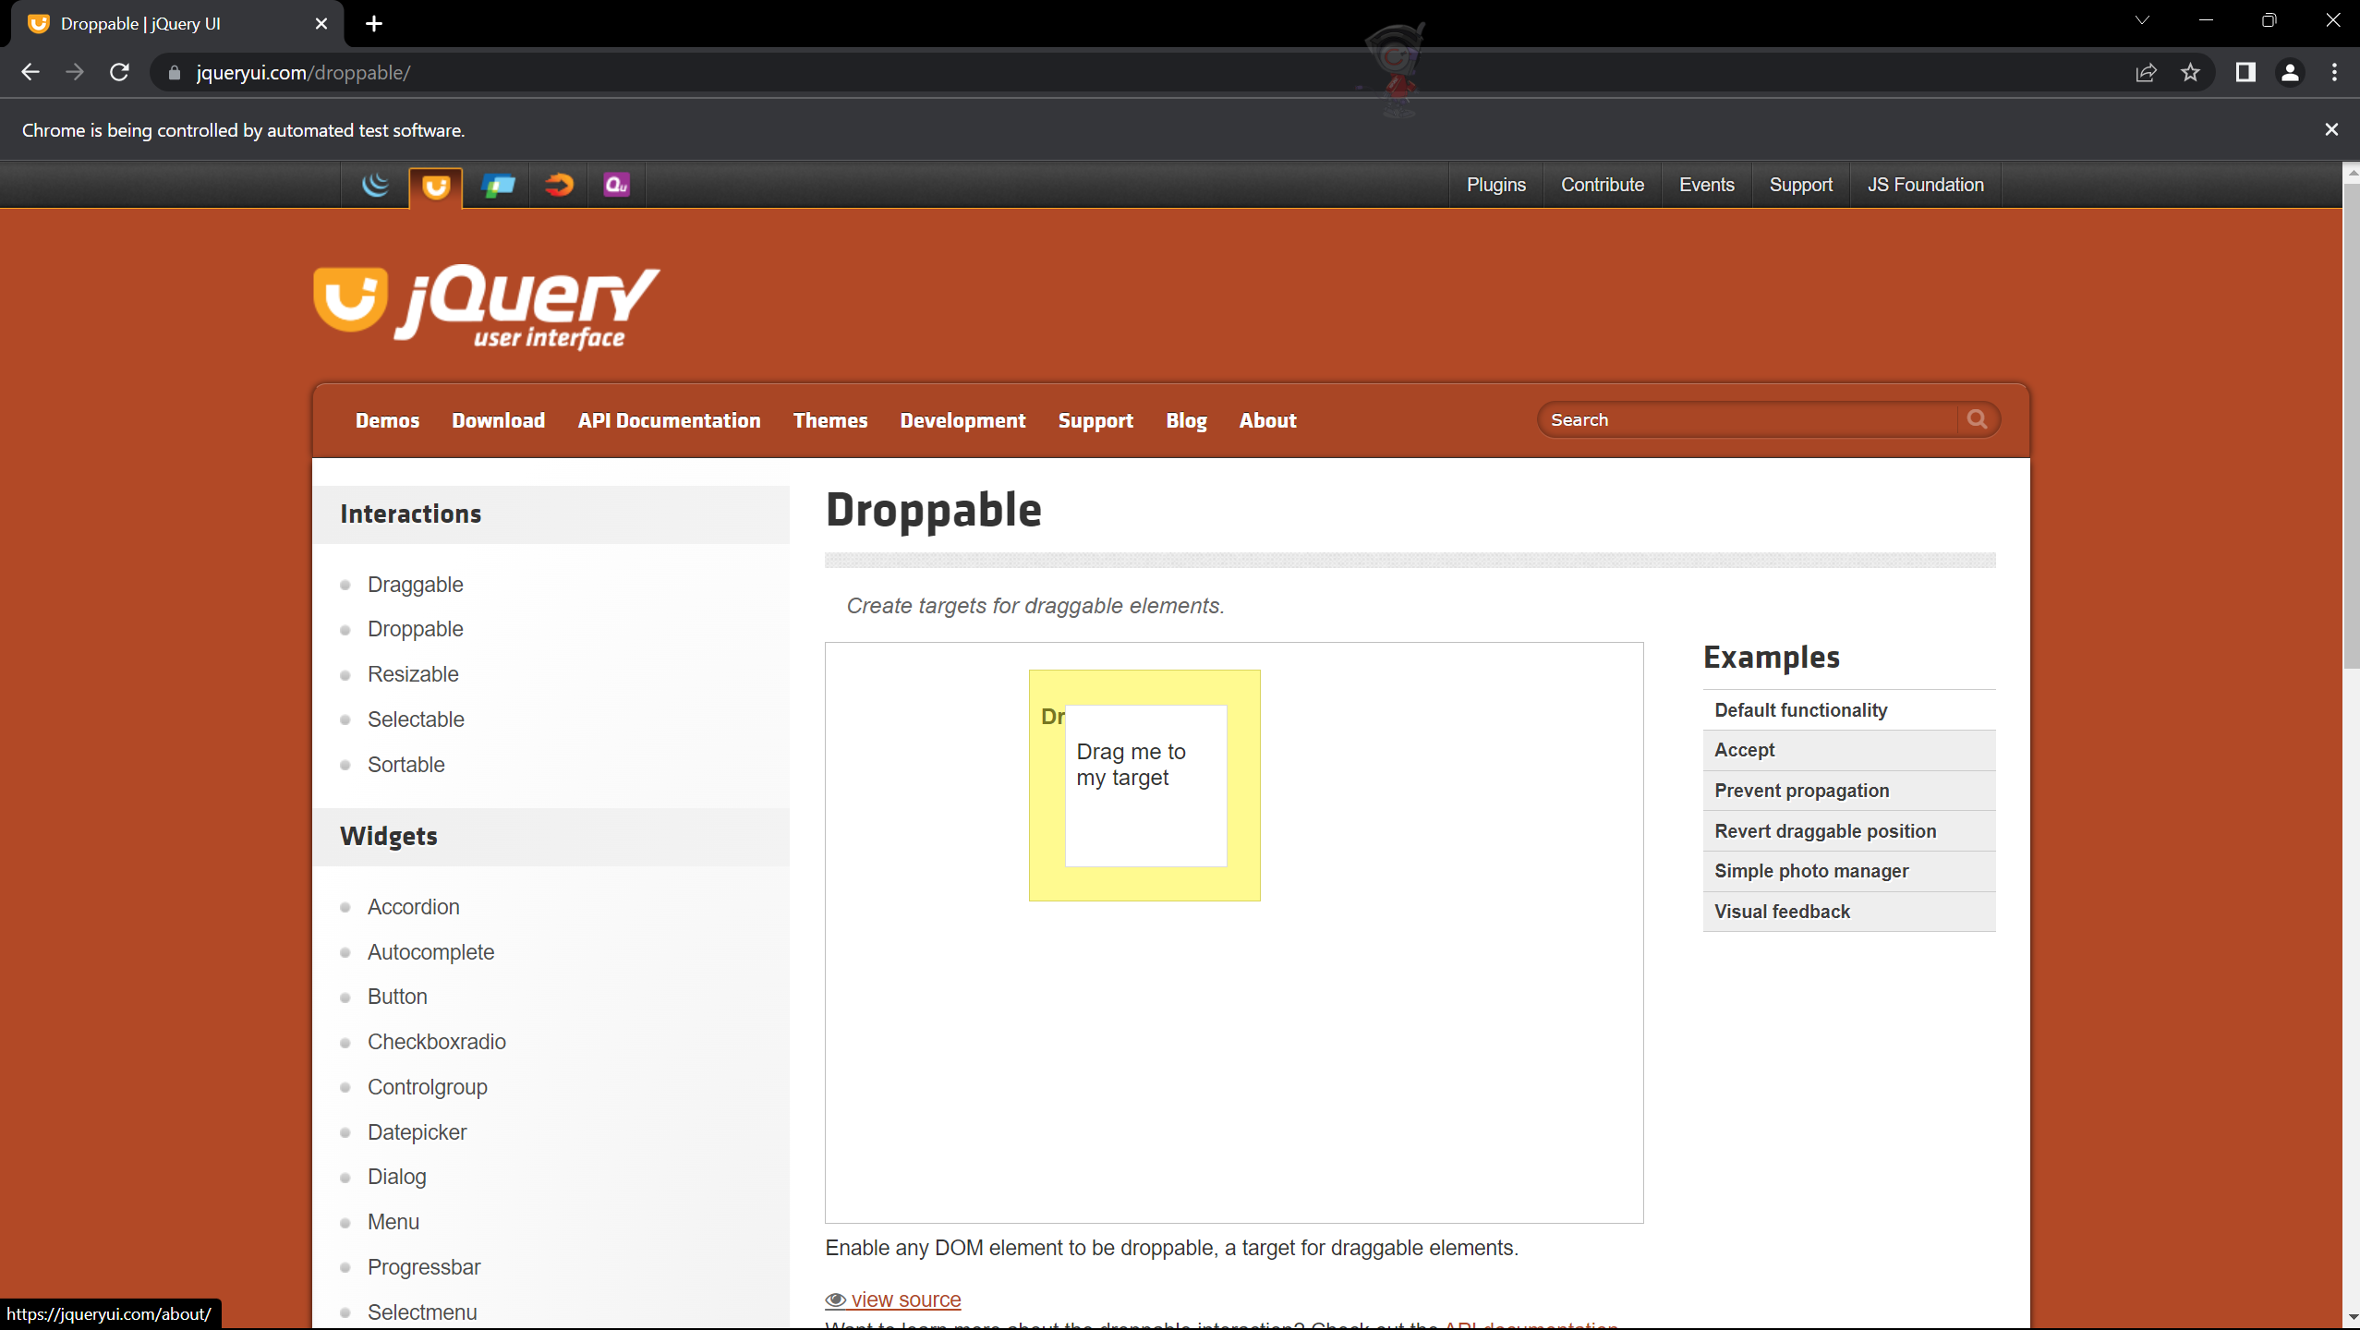

Task 3:

package day_5;

import org.openqa.selenium.Alert;

import org.openqa.selenium.By;

import org.openqa.selenium.WebDriver;

import org.openqa.selenium.WebElement;

import org.openqa.selenium.chrome.ChromeDriver;

import org.openqa.selenium.chrome.ChromeOptions;

import io.github.bonigarcia.wdm.WebDriverManager;

public class task3 {

public static void main(String[] args) {

System.setProperty("webdriver.chrome.driver","c://Drivers//chromedriver.exe" );

ChromeOptions co=new ChromeOptions();

co.addArguments("--remote-allow-origin=*");

WebDriver driver=new ChromeDriver(co);

driver.get("https://demo.guru99.com/test/delete_customer.php");

WebElement inp= driver.findElement(By.xpath("/html/body/form/table/tbody/tr[2]/td[2]/input"));

inp.sendKeys("401");

WebElement sub= driver.findElement(By.xpath("/html/body/form/table/tbody/tr[3]/td[2]/input[1]"));

sub.click();

Alert alert1=driver.switchTo().alert();

alert1.dismiss();

inp.clear();

inp.sendKeys("402");

sub.click();

Alert alert2=driver.switchTo().alert();

alert2.accept();

}

}

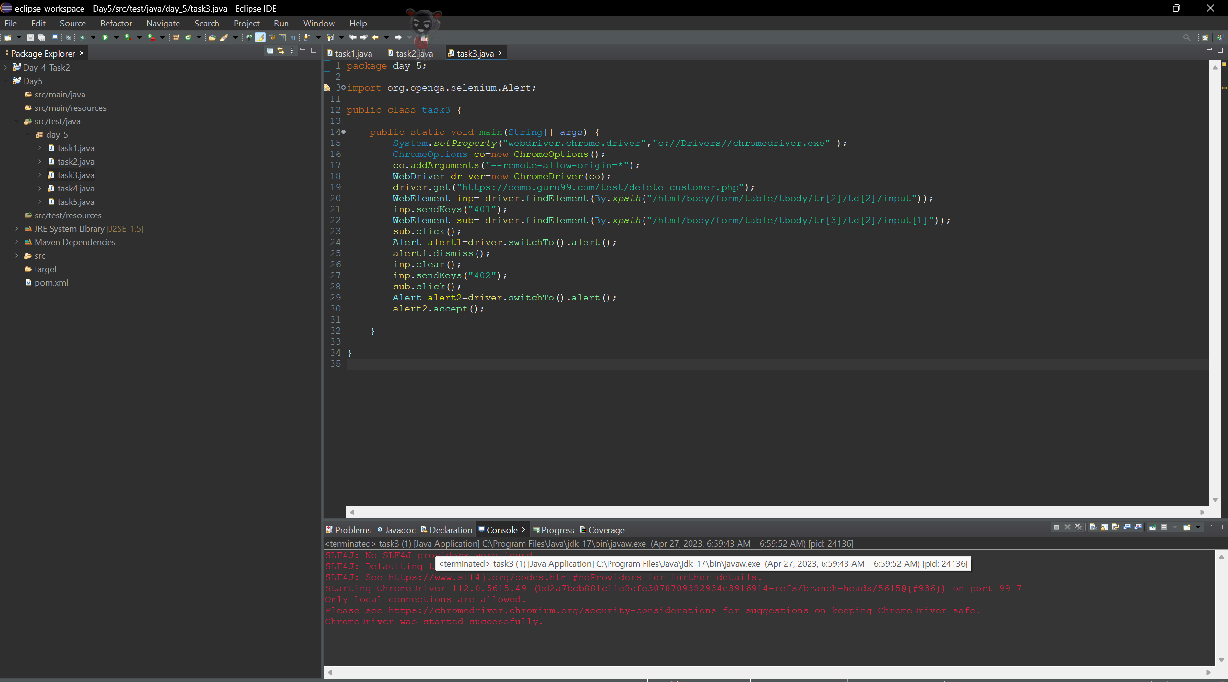

**Output:**

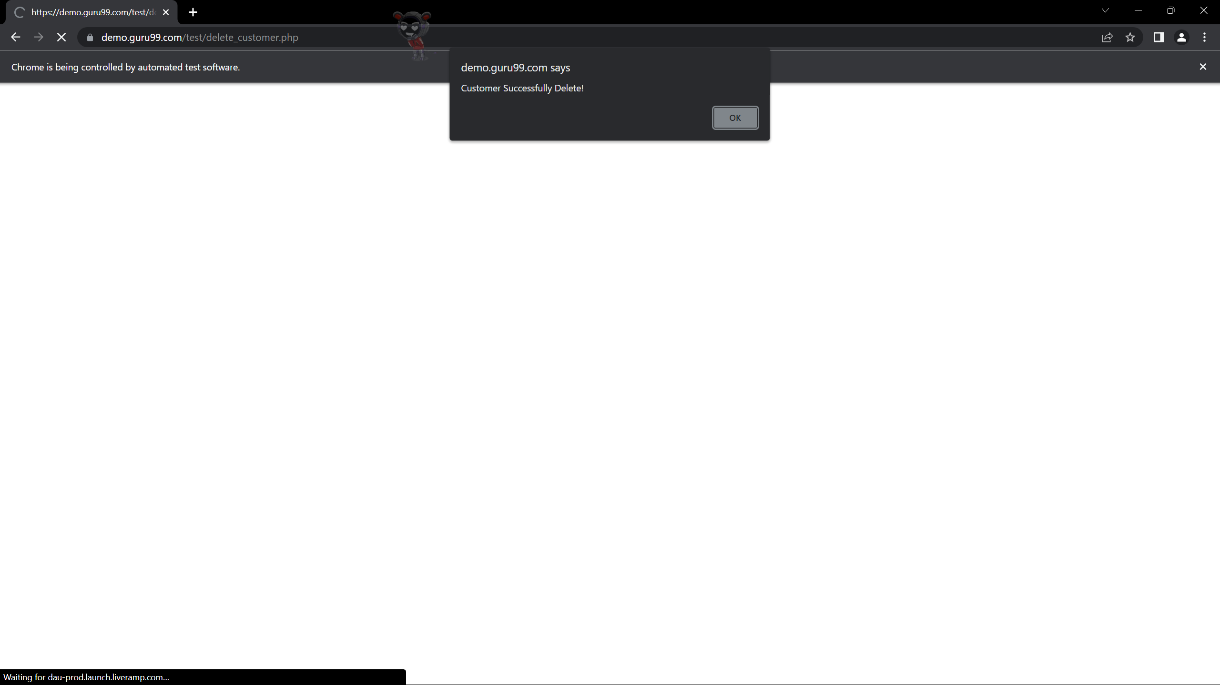

**Task 4:**

package day_5;

import org.openqa.selenium.By;

import org.openqa.selenium.JavascriptExecutor;

import org.openqa.selenium.Keys;

import org.openqa.selenium.WebDriver;

import org.openqa.selenium.WebElement;

import org.openqa.selenium.chrome.ChromeDriver;

import org.openqa.selenium.chrome.ChromeOptions;

import io.github.bonigarcia.wdm.WebDriverManager;

public class task4 {

public static void main (String [] args) throws InterruptedException {

System.setProperty("webdriver.chrome.driver","c://Drivers//chromedriver.exe" );

//WebDriverManager.chromedriver () . setup () ;

WebDriver driver;

ChromeOptions co = new ChromeOptions () ;

co.addArguments ("--remote-allow-origins=*");

driver=new ChromeDriver (co) ;

driver.get ("https://www.abhibus.com/bus-ticket-booking");

WebElement source=driver.findElement(By.id("source"));

source.sendKeys("Coimbatore");

Thread.sleep(3000);

source.sendKeys(Keys.ENTER);

WebElement destination=driver.findElement(By.id("destination"));

destination.sendKeys("Goa");

Thread.sleep(3000);

destination.sendKeys(Keys.ENTER);

WebElement date= driver.findElement(By.id("datepicker1"));

JavascriptExecutor js=(JavascriptExecutor)driver;

js.executeScript("arguments[0].setAttribute('value','04-05-2023')",date);

WebElement ser= driver.findElement(By.id("seo_search_btn"));

ser.click();

}

}

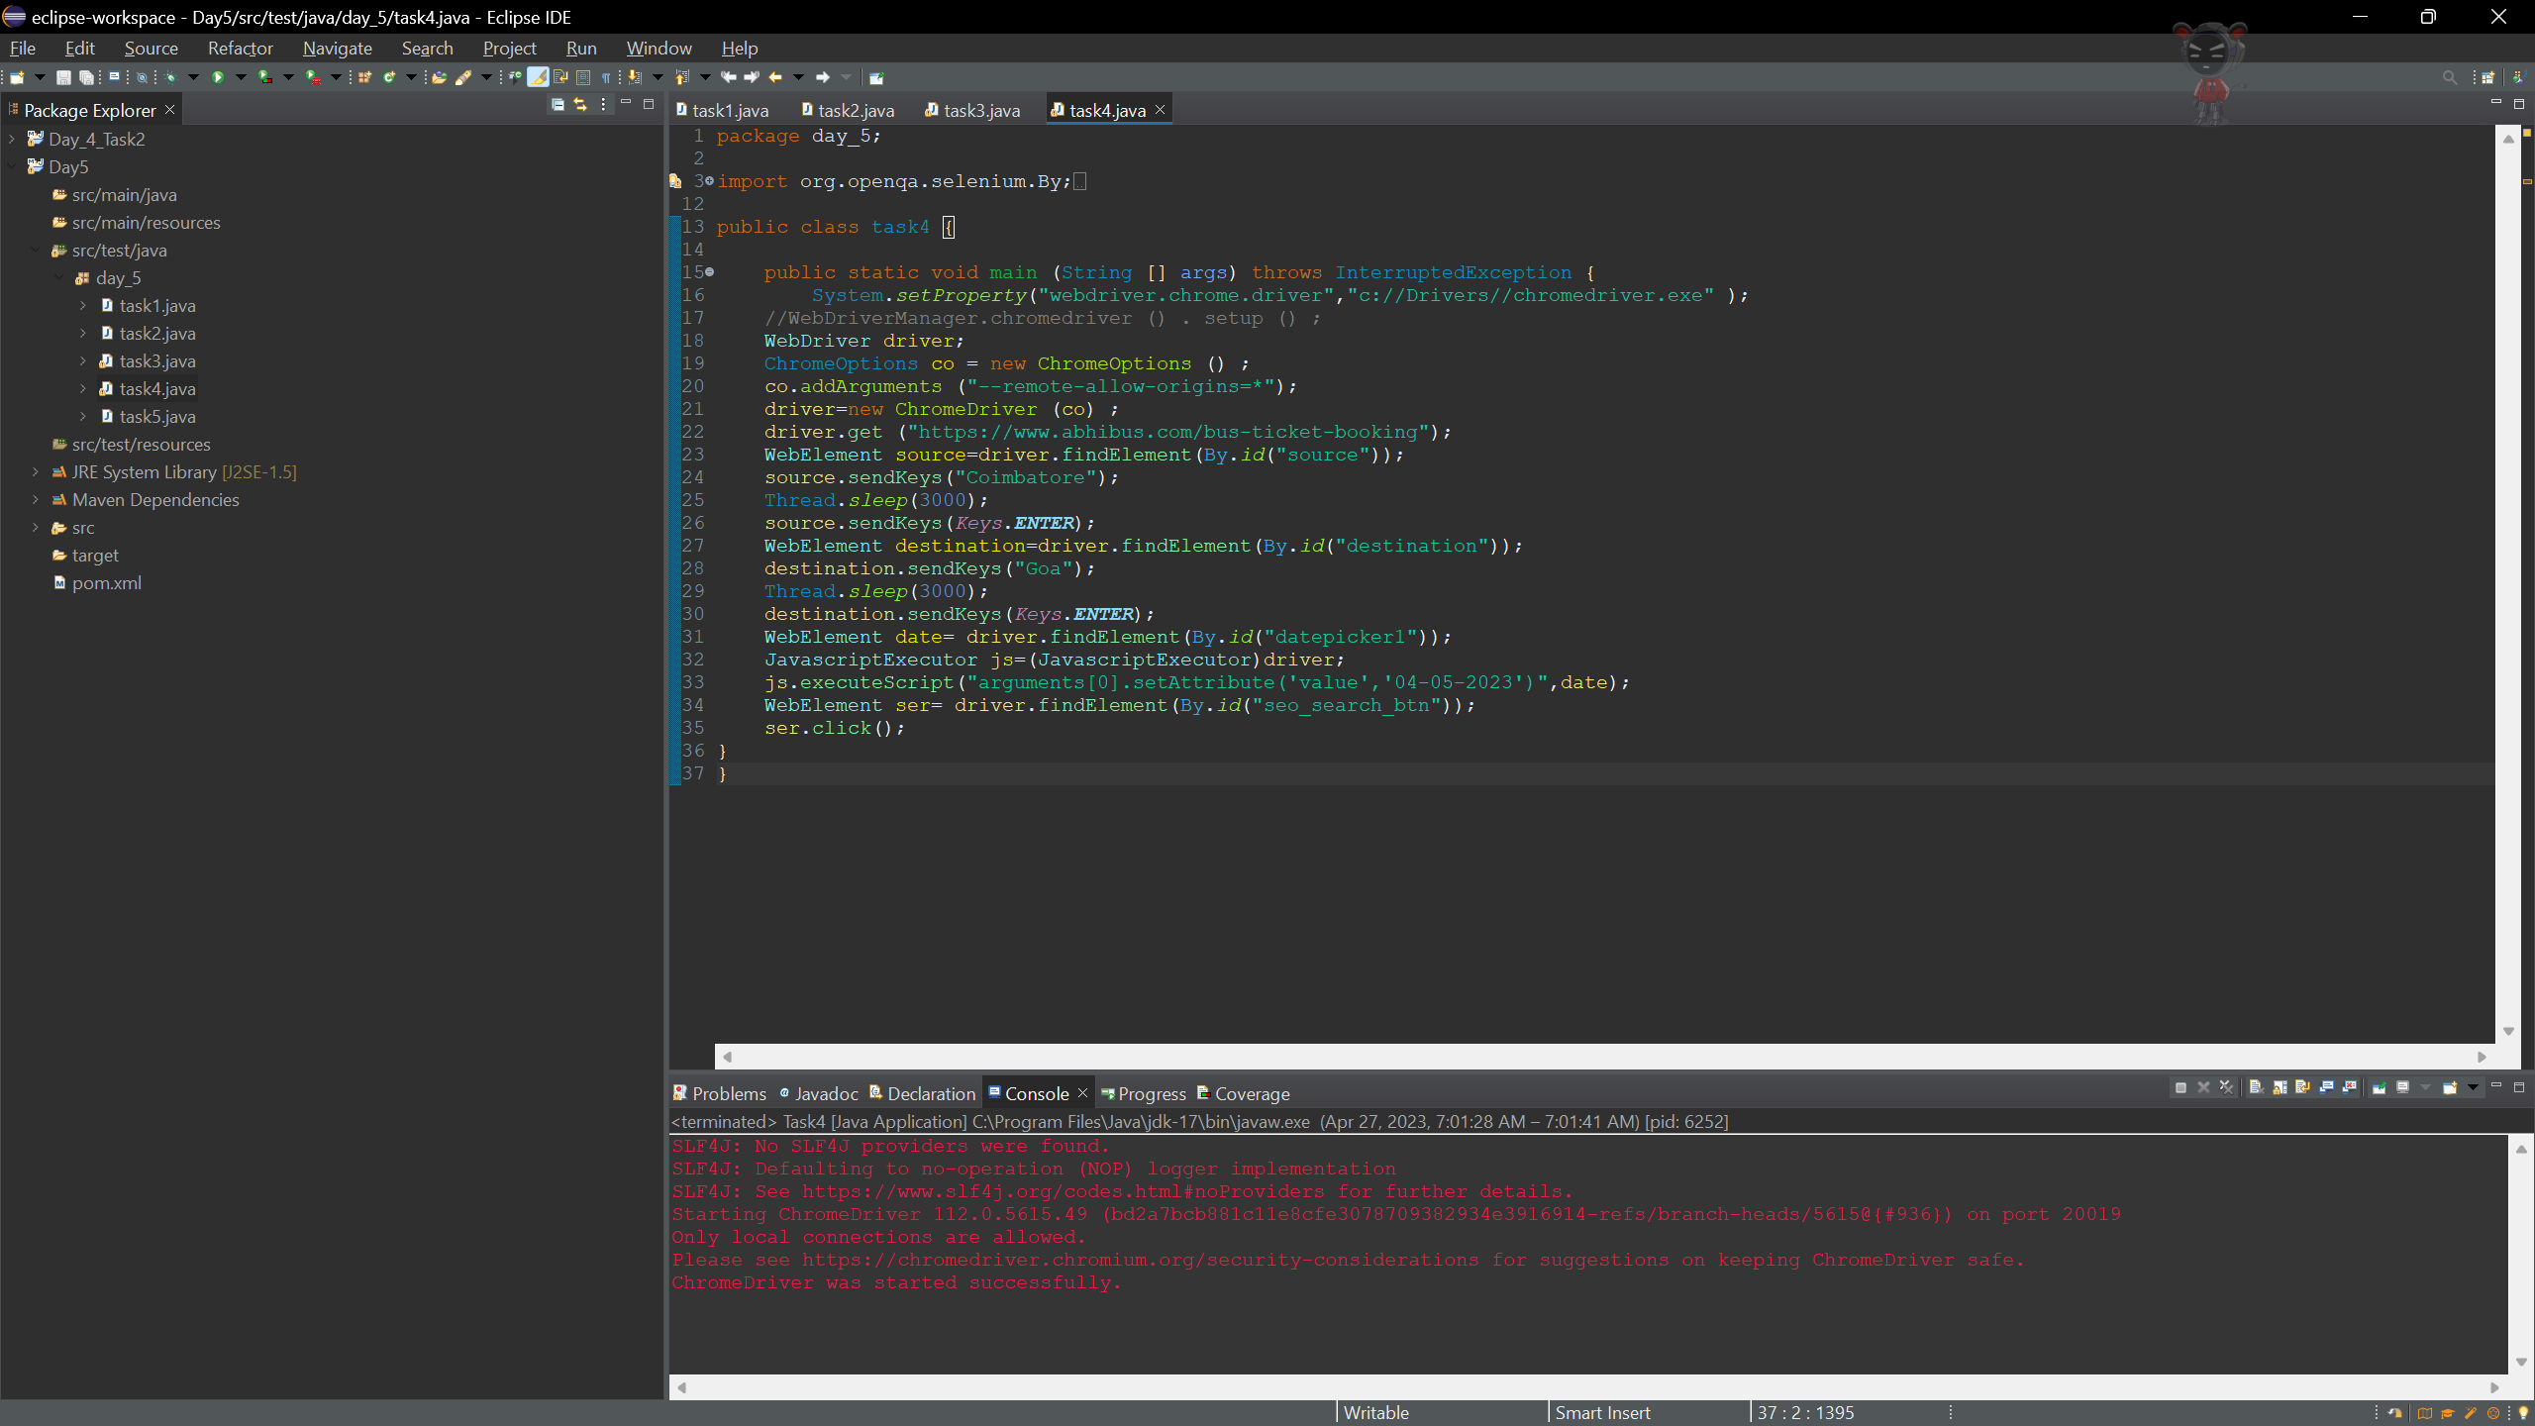

**Output:**

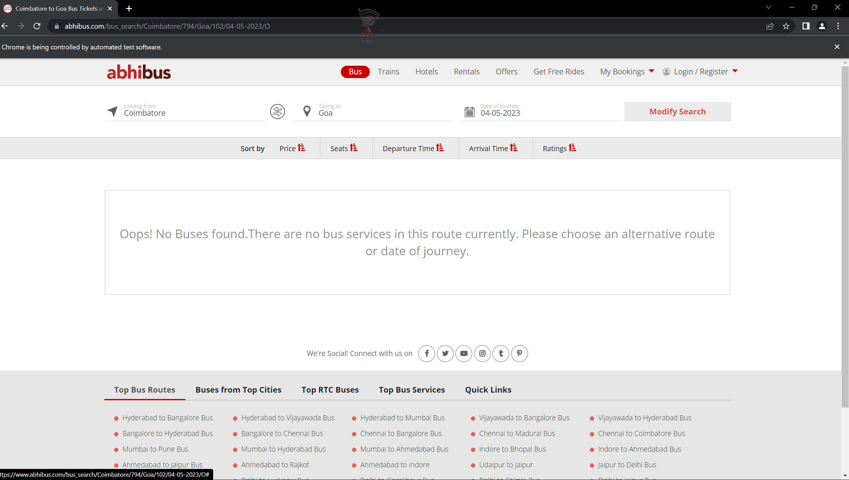

**Task 5:**

package day_5;

import java.util.Set;

import org.openqa.selenium.By;

import org.openqa.selenium.Keys;

import org.openqa.selenium.WebDriver;

import org.openqa.selenium.WindowType;

import org.openqa.selenium.chrome.ChromeDriver;

import org.openqa.selenium.chrome.ChromeOptions;

import io.github.bonigarcia.wdm.WebDriverManager;

public class task5 {

public static void main(String[] args) {

// TODO Auto-generated method stub

//WebDriverManager.chromedriver().setup();

System.setProperty("webdriver.chrome.driver","c://Drivers//chromedriver.exe" );

ChromeOptions co=new ChromeOptions();

co.addArguments("--remote-allow-origin=*");

WebDriver driver=new ChromeDriver(co);

driver.get("https://www.google.com");

driver.manage().window().maximize();

driver.findElement(By.name("q")).sendKeys("Apple");

driver.findElement(By.name("q")).sendKeys(Keys.ENTER);

System.out.print("\n"+driver.getWindowHandle());

System.out.print("\n"+driver.getTitle());

driver.switchTo().newWindow(WindowType.TAB);

driver.get("https://www.google.com");

driver.findElement(By.name("q")).sendKeys("Selenium");

driver.findElement(By.name("q")).sendKeys(Keys.ENTER);

System.out.print("\n"+driver.getWindowHandle());

System.out.print("\n"+driver.getTitle());

driver.switchTo().newWindow(WindowType.TAB);

driver.get("https://www.google.com");

driver.manage().window().maximize();

driver.findElement(By.name("q")).sendKeys("cucumber");

driver.findElement(By.name("q")).sendKeys(Keys.ENTER);

System.out.print("\n"+driver.getWindowHandle());

System.out.print("\n"+driver.getTitle());

Set<String>s=driver.getWindowHandles();

System.out.println("Number of windows opened="+s.size());

}

}

**Output:**

